**Project Report On**

Talk Your Doc +

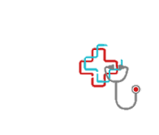

Submitted in partial fulfillment for the award of

**PG-Diploma in Advance Computing (PG-DAC) from C- DAC, ACTS (Pune)**



**Guided by:**

**Ms. Kishori KhadilKar Presented by:**

**Ms. Bhagyashree Dembla PRN: 210940120038 Ms. Nikita Gopal Gholave PRN: 210940120128**

**Ms. Nikita Shinde PRN: 210940120129**

**Mr. Nitish Kumar Singh PRN: 210940120132 Mr. Patil Ajinkya Sambhaji PRN: 210940120145**

**Mr.Rushikesh Vijaykumar Ambure PRN: 210940120176**

**Centre for Development of Advanced Computing (C-DAC), Pune.**

**ACKNOWLEDGEMENT**

The project “**Talk Your Doc**” is a great learning experience for us and we are submitting our work to Advanced Computing Training School (CDAC ACTS), Pune.

We are glad to mention name of *Ms. Kishori Khadilkar* for her valuable guidance on this project. Her guidance and support helped us to overcome various obstacles and intricacies during the course of project work.

We are highly grateful to Ms. Risha P.R. (Manager, ACTS), CDAC, Pune, for her guidance and support whenever necessary during our course PG-Diploma in *Advance Computing (PG-DAC)* through C-DAC ACTS, Pune.

Our heartfelt thanks goes to *Ms. Shilpi Shalini* (Course Coordinator, *PG*-*DAC*) who gave all the required support and kind coordination to provide all the necessities to complete the project and throughout the course up to the last day here at C-DAC ACTS, Pune.

|  |  |
| --- | --- |
| **From:** |  |
| Ms.Bhagyashree Dembla | (210940120038) |
| Ms. Nikita Gopal Gholave | (210940120128) |
| Ms. Nikita Shinde | (210940120129) |
| Mr. Nitish Kumar Singh | (210940120132) |

Mr. Patil Ajinkya Sambhaji (210940120145)

Mr.Rushikesh V. Ambure (210940120128)

**Table of Contents**

* Introduction of Project
* Product Overview and Summary
  + Purpose
  + Scope
  + Overview
  + Feasibility Study
  + Survey Certificate
* Overall Description
  + Product
  + Feature
  + User Classes
  + General Constraints
* Functional Requirements
* Design
  + Database Design
  + ER Diagram

# Introduction of Project:

As much as we like to travel or move to new places either for the purpose of study or work we are constantly worried about one thing, what if I get sick. Where will I find a good doctor? Who will take care of me? In this web application we tried to provide a one stop solution to all these problems.

This web application provides the facility to book appointments online with specialists in user’s locality. A user can look for a doctor based on his specialties and location, and then pick a time slot and book the appointment. The aim of our project is to bridge the gap between a patient and a doctor.

Talk Your Doc is an error free, secure, reliable and fast web application. It will allow people to travel or move to new cities without worrying about their health. Anyone can consult with a doctor anytime anywhere. All it needs is a web browser and internet connection.

This project is inspired form post pandemic events when demands for medical attention were more than medical services provided. Our aim is to provide ease of consultation with a doctor and getting required treatment, along with that saving time of both doctors and patients.

One important point is that we do not provide home visit feature yet but we significantly reduce time of booking an appointment so you no longer have to wait in long queues.

# Product Overview and Summary

## Purpose:

The purpose of our Project “Talk Your Doc” is to automate the process of getting medical treatment and health checkup in a way that saves both time and effort. It manages all the information of patient and doctors. The project is developed at administrative end and thus only the administrator is guaranteed to have access to everything. The purpose of this project is to create a web application that reduces the manual efforts of looking for a doctor and booking appointments.

## Scope:

“Talk Your Doc” is a web application that can be used by anyone anywhere whenever they fell sick and are in need of medical treatment or just wants to get a routine checkup. This service is also a boon for those young doctors who just started their practice.

The application provides a user-friendly interface to search for doctors of different specializations in the user’s proximity.

## Overview:

Section 3.0, the Overall Description, provides an overview of the components and the relationship between them. Section 4.0 provides the Specific Requirements of the product. In the subsection (4.1) of which the various functional requirements and various interface respectively are discussed. Section 5.0 describes Database Design details.

## Feasibility Study

It is important to analyze whether it is feasible to develop a project or not and that can it be completed in given time or not.

Before developing and implementing a system we have to make sure that the system is feasible in the following ways:

## Technical Feasibility

1. **Operational Feasibility**
2. **Economical Feasibility**
   * **Technical Feasibility:**

In this type of feasibility study, the system analyst has to check whether it is possible or not to develop the requested system with availability of manpower, software, hardware, etc.

## Operational Feasibility:

In this type of feasibility study the operation implementation of the system is considered. Checking is done regarding whether it is feasible for the user department to use the framework. Thus, the proposed system is said to be operationally feasible only if the clients are able to understand the system clearly and correctly and can use the system with ease.

## Economical Feasibility:

In this type of feasibility study, the benefits of the system to the organization are considered by taking into consideration the cost-benefit analysis. The minimal requirement for this is a computer and an internet connection, which is available to everyone nowadays. Also, with the basic understanding user can use this system, thus reducing the training cost to the organization.

## Product Features

The main feature of this system is that the users can book an appointment from doctors nearby. This is beneficial for both patient and doctor as it saves their precious time & efforts. Users can also look for blood donors.

## Technologies Used BACK END

J2EE

Spring-boot

## DATABASE

MYSQL

## FRONT END

React JS Bootstrap

## User Classes

There are three types of user to this system:

1.) **Admin**: Admin can add or remove both doctors and blood donors; additionally admin can remove patients as well. He/she also maintains the overall system.

2.) **Patient**: Patients can pick a time slot of their convenience and book appointments with doctors nearby. Patients can view their appointment history as well.

3.) **Doctor**: Doctor can receive appointment details of patient. Doctors can create appointment time slots as per their convenience. A doctor can also cancel his/her appointment with a patient in case of emergency.

## General Constraints

The “Talk Your Doc” application should run on all desktop computers having a web browser with stable internet connection.

## 4.1 FUNCTIONAL REQUIREMENTS

**ADMIN**

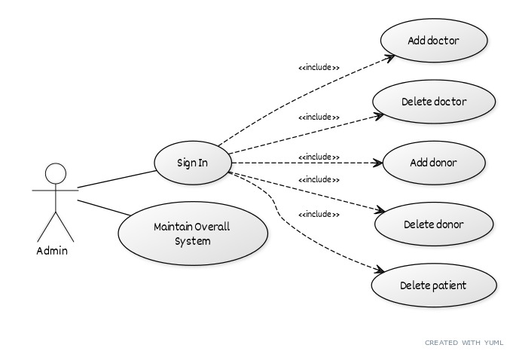

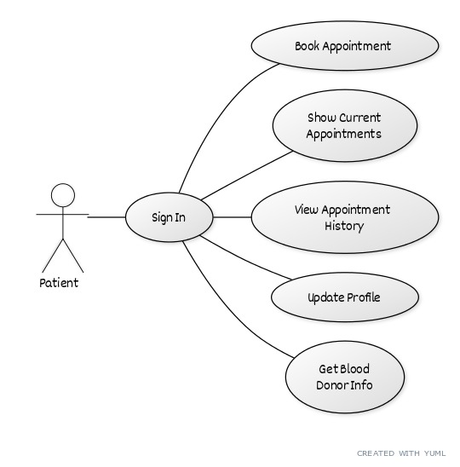

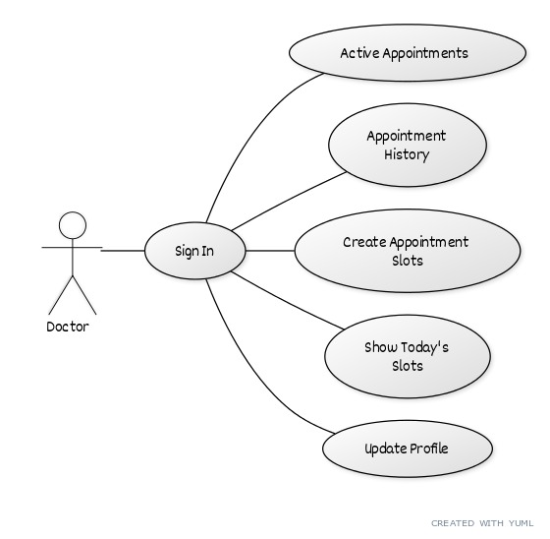

# Design:

## Database Design

The following table structures depict the database design.

## Table 1: Patient

|  |  |  |  |  |
| --- | --- | --- | --- | --- |
| Key Type/ Constraint | Column Name | Data Type | Length | Allow Null (1=Yes;0=No) |
| PK | id | int |  | 0 |
|  | first_name | varchar | 30 | 1 |
|  | last_name | varchar | 30 | 1 |
| UK | email | varchar | 30 | 1 |
|  | mobile_number | varchar | 13 | 0 |
|  | password | varchar | 30 | 0 |
| UK | username | varchar | 30 | 1 |
|  | dob | date |  | 1 |
|  | gender | varchar | 20 | 1 |
|  | area | varchar | 50 | 1 |
|  | city | varchar | 30 | 1 |
|  | state | varchar | 30 | 1 |

**Table 2: Admin**

|  |  |  |  |  |
| --- | --- | --- | --- | --- |
| Key Type/ Constraint | Column Name | Data Type | Length | Allow Null (1=Yes;0=No) |
| PK | id | int |  | 0 |
|  | email | varchar | 20 | 0 |
|  | name | varchar | 20 | 0 |
|  | password | varchar | 20 | 0 |

**Table 3: Doctor Table**

|  |  |  |  |  |
| --- | --- | --- | --- | --- |
| Key Type/ Constraint | Column Name | Data Type | Length | Allow Null (1=Yes;0=No) |
| PK | id | int |  | 0 |
|  | first_name | varchar | 30 | 1 |
|  | last_name | varchar | 30 | 1 |
|  | password | varchar | 30 | 0 |
| UK | username | varchar | 30 | 1 |
|  | dob | date |  | 1 |
|  | gender | varchar | 20 | 1 |
|  | mobile_number | varchar | 13 | 0 |
|  | area | varchar | 50 | 1 |
|  | city | varchar | 30 | 1 |
|  | state | varchar | 30 | 1 |
|  | fees | int |  | 1 |
|  | languages | varchar | 30 | 1 |
|  | qualification | varchar | 30 | 1 |
|  | specialization | varchar | 30 | 1 |
| UK | email | varchar | 30 | 1 |
|  | began_practice | date |  | 1 |
|  | time_slot_id | int |  | 1 |

**Table 4: Appointment Table**

|  |  |  |  |  |
| --- | --- | --- | --- | --- |
| Key Type/ Constraint | Column Name | Data Type | Length | Allow Null (1=Yes;0=No) |
| PK | id | bigint |  | 0 |
|  | appointment_time | datetime | 6 | 1 |
|  | appointment_type | varchar | 255 | 1 |
| FK | doctor_id | bigint |  | 0 |
| FK | patient_id | bigint |  | 0 |

**Table 5: Doctor Timetable**

|  |  |  |  |  |
| --- | --- | --- | --- | --- |
| Key Type/ Constraint | Column Name | Data Type | Length | Allow Null (1=Yes;0=No) |
| PK | id | bigint |  | 0 |
|  | break_time | time |  | 1 |
|  | Start_time | Time |  | 1 |
|  | End_time | Time |  | 1 |
|  | Start_date | Date |  | 1 |
|  | End_date | Date |  | 1 |
|  | Slot_duration | int |  | 0 |

**Table 6: Blood Donor**

|  |  |  |  |  |
| --- | --- | --- | --- | --- |
| Key Type/ Constraint | Column Name | Data Type | Length | Allow Null (1=Yes;0=No) |
| PK | id | bigint |  | 0 |
|  | name | varchar | 30 | 1 |
|  | email | varchar | 30 | 1 |
|  | contact_number | varchar | 13 | 1 |
|  | city | varchar | 30 | 1 |
|  | state | varchar | 30 | 1 |
|  | blood_group | varchar | 255 | 1 |
|  | units_of_blood | int |  | 1 |

**Table 7: Doctor Time Table Available Slots**

|  |  |  |  |  |
| --- | --- | --- | --- | --- |
| Key Type/ Constraint | Column Name | Data Type | Length | Allow Null (1=Yes;0=No) |
| PK | doctor_time_table_id | bigint |  | 0 |
|  | Available_slots | bit | 1 | 1 |
| CPK | available_slots_key | int |  | 0 |

**Table 8: Doctor Time Table Holiday**

|  |  |  |  |  |
| --- | --- | --- | --- | --- |
| Key Type/ Constraint | Column Name | Data Type | Length | Allow Null (1=Yes;0=No) |
| FK | doctor_time_table_id | bigint |  | 0 |
|  | holidays | varchar | 255 | 1 |

